**Covid Tracking App**

1. A link for a working angular application which pushed on github/ gitlab. (This code base should be without node_modules) – <https://github.com/PallaviSharmaNag/covidTrackingApp>
2. Documentation of the working of the application, any assumptions, creds to be logged in as an admin.  Upload the documentation in the github/gitlab itself.

**Login Creds :**

* pallavi, pallavi
* admin, admin

**StateWise Details:**

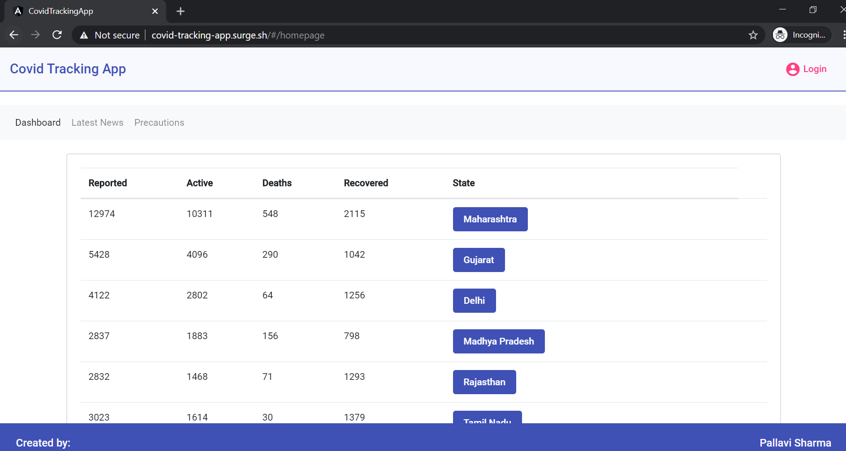

**District Wise details:**

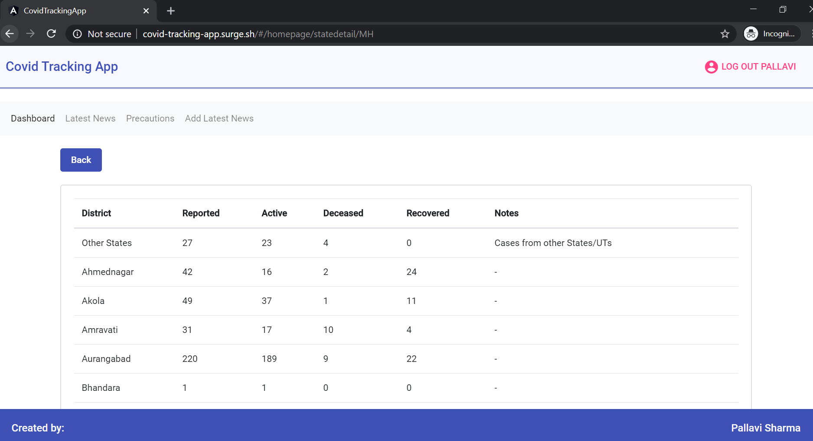

**Latest News:**

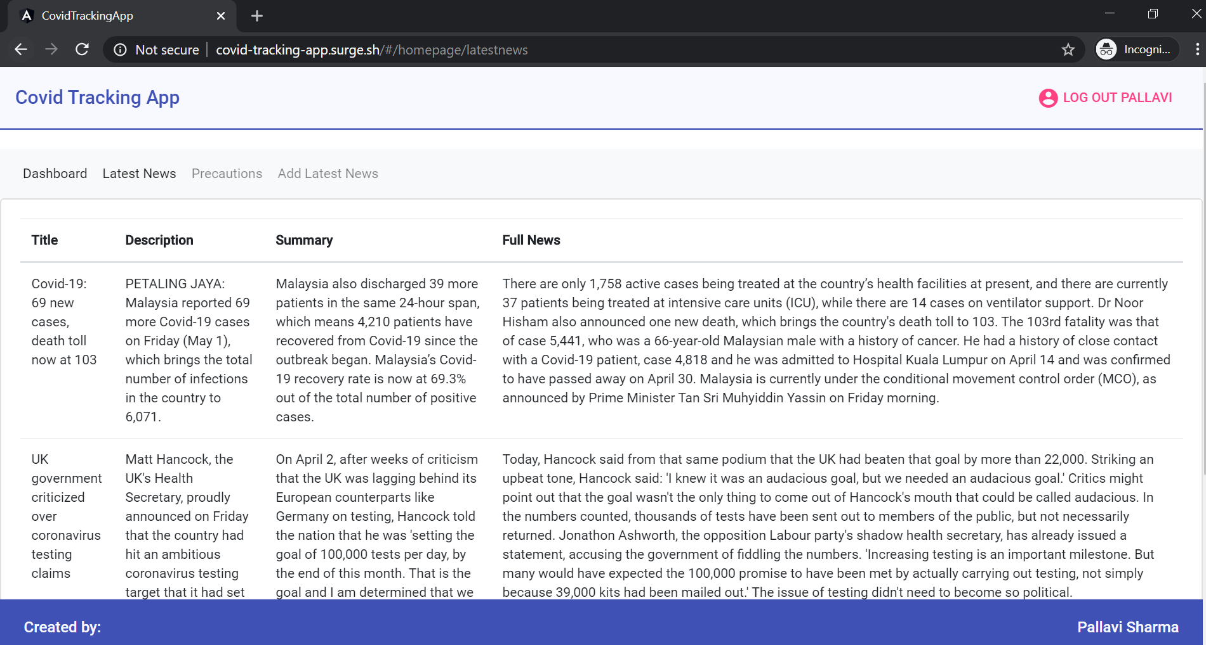

**Precautions:**

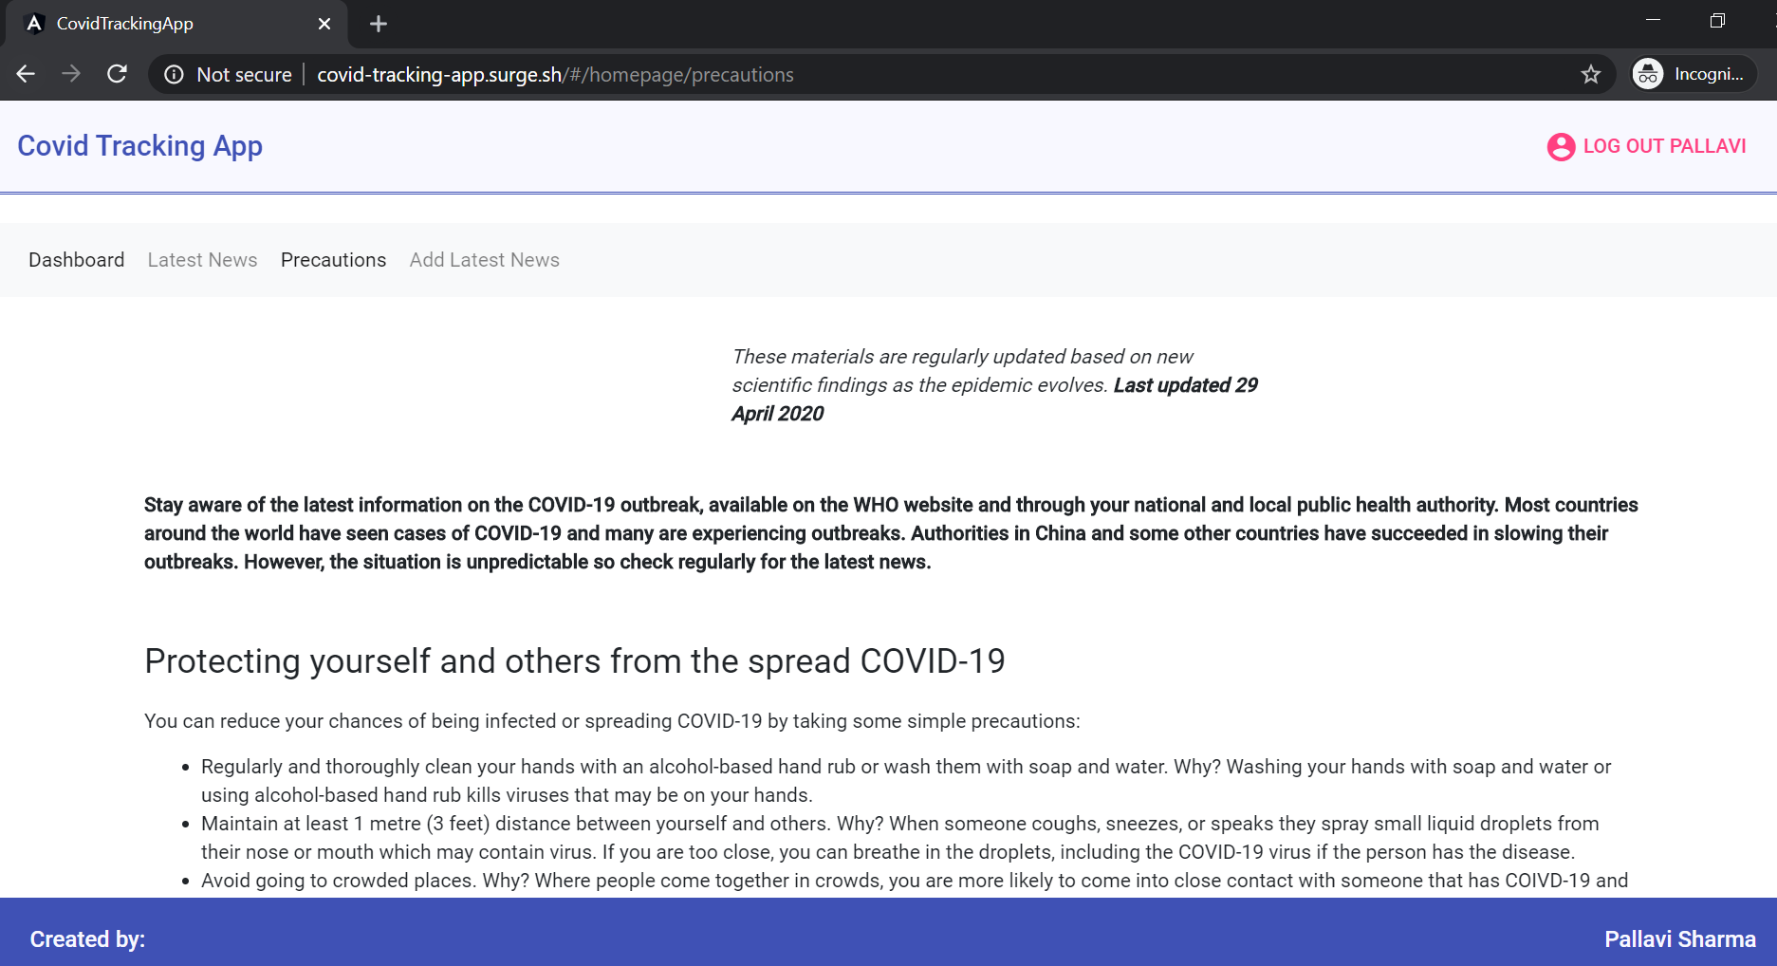

**Add latest News:**

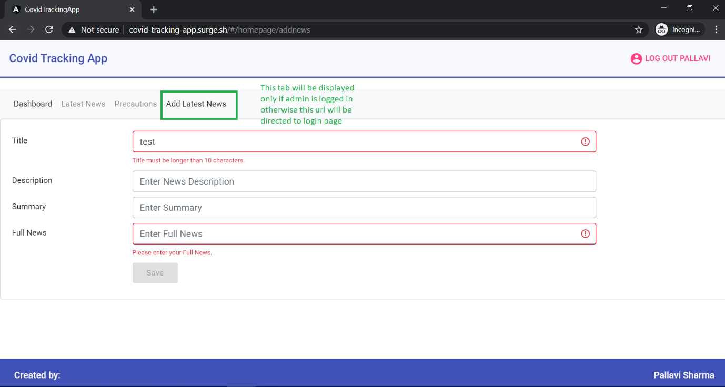

**Note:** Find out that there is no data corresponding to Nagaland in the api used to fetch district wise details [https://api.covid19india.org/state_district_wise.json](https://apc01.safelinks.protection.outlook.com/?url=https%3A%2F%2Fapi.covid19india.org%2Fstate_district_wise.json&data=02%7C01%7Caditi.bassi%40nagarro.com%7C6828174ff0ce41bb390008d7e393e94b%7Ca45fe71af4804e42ad5eaff33165aa35%7C0%7C0%7C637228096718459049&sdata=UXK0BOd6yLL3cZaeVWa0e%2BHgFCTwdu%2FXPupB%2BfjUPHs%3D&reserved=0). So if you click Nagaland, it will show no such state found, in that case.

1. Provide link for your deployed application on surge.sh or any other website you prefer that allows static website hosting. - <http://covid-tracking-app.surge.sh/>